Survey of end-users:

* I will use google forms to complete my survey. My survey will include questions about what should be included in my program and what restraints should be used. I will use the data in this survey to determine what I will include and how to design the interface in order to suit my target audience.

<https://docs.google.com/forms/d/e/1FAIpQLSdLkx__48oMPzzUTZNKA6raiHRtnr8JjpftN7_MSUGt7f_tmg/viewform?usp=sf_link>

Survey questions:

* What is your name
* How many chance and community chest cards should I use?
* How many players should be able to play in my game?
* Should I use buttons for actions (buy, roll dice and buy houses etc) or ask users to type action into a window?
* How many dice should I use?
* Should I use the £ sign or the $ sign for the money?
* Do you enjoy a game of monopoly?

Survey responses:

| Timestamp | What is your name | How many chance and community chest cards should I use? | How many players should be able to play in my game? | Should I use buttons for actions (buy, roll dice and buy houses etc) or ask users to type actions into a window? | How many dice should I use? | Should I use the £ sign or the $ sign for the money? | Do you enjoy a game of monopoly? |
| --- | --- | --- | --- | --- | --- | --- | --- |
| 05/09/2018 15:44:32 | Ricky | Between 10 and 15 | 2 players | Buttons | 2 dice | £ | Yes |
| 05/09/2018 15:45:05 | Miss K | Between 5 and 10 | 1 player | Buttons | 2 dice | £ | Yes |
| 05/09/2018 15:45:22 | Declan | Between 10 and 15 | 2 players | Buttons | 2 dice | £ | Yes |
| 05/09/2018 15:45:24 | Rory Owens | Between 1 and 5 | 2 players | Buttons | 1 die | £ | Yes |
| 05/09/2018 15:45:57 | Catherine Fitzsimons | Between 1 and 5 | 2 players | Buttons | 2 dice | £ | Yes |
| 05/09/2018 15:46:19 | Rachel Cooper | Between 5 and 10 | 2 players | Buttons | 2 dice | £ | Yes |
| 05/09/2018 15:46:59 | Amina Tahir | Between 10 and 15 | More than 2 players | Buttons | 2 dice | £ | Yes |
| 05/09/2018 15:49:17 | Harris Malone | More than 15 | 2 players | Buttons | 2 dice | £ | Yes |
| 06/09/2018 12:19:33 | Finlay Gilfillan | Between 1 and 5 | 1 player | Buttons | 1 die | £ | Yes |
| 07/09/2018 09:31:45 | Jake | Between 10 and 15 | 2 players | Buttons | 2 dice | £ | Yes |
| 10/09/2018 10:58:21 | Tomasz | Between 10 and 15 | 2 players | Buttons | 2 dice | £ | Yes |
| 12/09/2018 14:46:03 | John Neilson | More than 15 | More than 2 players | Type inputs | 3 dice | £ | Yes |
| 13/09/2018 11:25:39 | Josh Jones | Between 10 and 15 | More than 2 players | Buttons | 2 dice | £ | Yes |
| 13/09/2018 11:29:29 | Omar Ahmed | More than 15 | More than 2 players | Buttons | 2 dice | £ | Yes |
| 13/09/2018 11:37:51 | Abdullah Irfan | Between 10 and 15 | More than 2 players | Buttons | 2 dice | $ | Yes |

Survey Responses as chart:

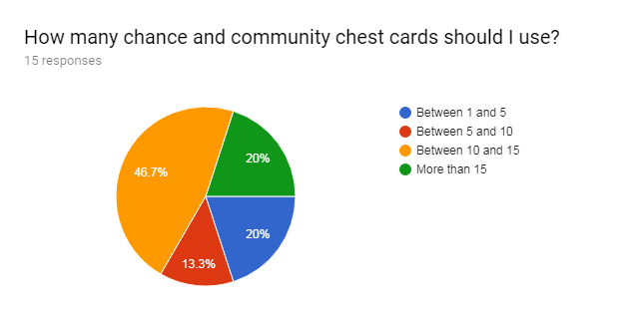

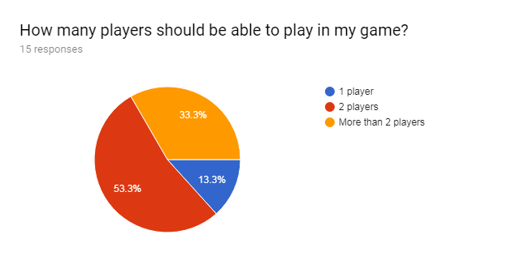

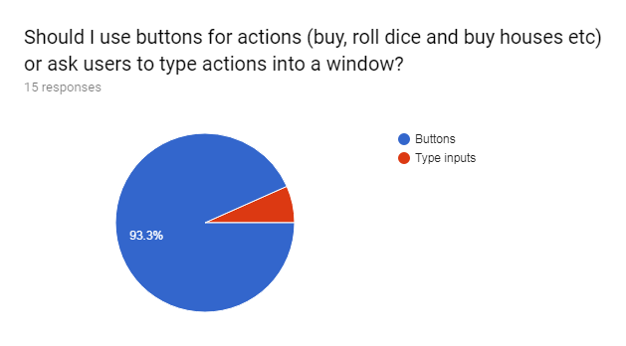

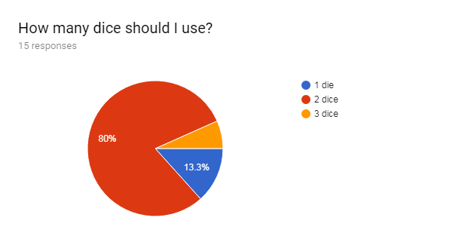

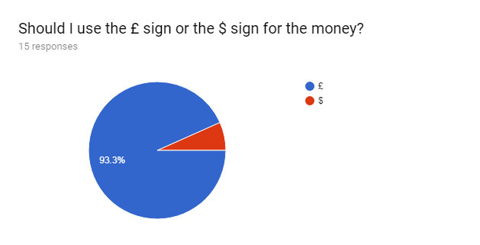

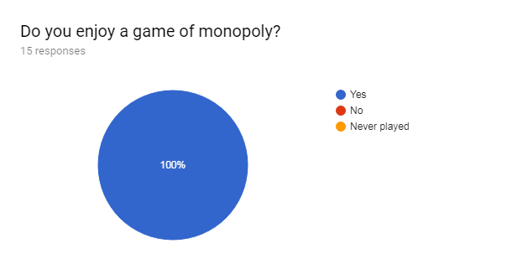

Analysis of findings:

* How many chance and community chest cards should I use?
  + The majority vote was for between 10 and 15 cards, in my program I will achieve this to suit my users requirements.
* How many players should be able to play in my game?
  + The majority vote was for 2 players to be able to play my game, in my program I will do this to suit my users requirements.
* Should I use buttons for actions (buy, roll dice and buy houses etc) or ask users to type action into a window?
  + Because the majority vote was to use buttons as an input method, in my program I will do this to suit my users requirements.
* How many dice should I use?
  + The majority voted to use two dice, in my program I will do this to suit my users requirements.
* Should I use the £ sign or the $ sign for the money?
  + The majority voted in favor of using the pound sign, in my program I will do this to suit my users requirements.
* Do you enjoy a game of monopoly?
  + The majority of users voted yes.

I will do all of these things in order to meet my users requirements.